A recent addition to the Franchise Site includes a Physical Inventory tool. Before we begin the details of how to use the Kilwin’s Physical Inventory feature, we should first briefly outline the basics of the physical inventory process.

The Basics

Why do a physical inventory?
- It is a key measuring tool of the health of our business
- Provides an accurate Cost of Goods % by department
- Provides an accurate bottom line
- Provides a snapshot of assets on hand
- An accurate inventory value must be stated at FYE
- Can identify operational problems (pricing issues, theft, spoilage, product rotation, portion controls, etc.)
- Can give you a positive validation

How often should a physical inventory be taken?
  - Annually at a minimum
  - Monthly is recommended

How do we prepare to take a physical inventory?
    - Commit and make it a priority
    - Schedule a date and start planning
    - Organize your store
    - Make sure all items are set up as “My Items”
    - Train managers and staff who will assist
    - Understand units of measure
    - Use a methodical approach to counting items in the store

What is the process of taking a physical inventory?
- Print count sheets
- Physically count all inventory in the store
- Enter the counts
- Identify any discrepancies and correct
- Create an inventory valuation
- Make adjustment journal entries
- Analysis of Cost of Goods % and follow up

Overview

This system uses the web in conjunction with Microsoft Excel to capture items, print count sheets, enter the counts for items and print the inventory valuation reports for the store. You can opt to count a group of items or all items during a physical inventory. Kitchen-purchased items, made in store (MIS) items as well as vendor-purchased items may be included in the physical inventory.

All Kilwin’s items (Kitchen items and MIS items) have been assigned a Physical Inventory Classification and an Accounting Classification. Both classifications can be found listed on each item’s detail page for reference use.

The Physical Inventory Classifications are listed below. The aim is to group similar items together on the count sheets to make the actual counting and recording more efficient.

Physical Inventory Classifications |  | Physical Inventory Classifications |  | Physical Inventory Classifications
Apples |  | Fruits |  | Paper Plastic
Baskets |  | Fudge |  | Plates
Beverages |  | Ice Cream |  | Pre-Packaged
Box Chocolates |  | Ingredients |  | Ribbon, Wrap & Picks
Bulk Candy |  | Krispies |  | Rods
Chocolates |  | Labels |  | Shortbread/Biscotti
Christmas |  | Marshmallows |  | Sugar Free
Corns & Brittles |  | Miscellaneous |  | Twists
Easter |  | Molded Items |  | Valentines
Fall/Halloween |  | Oreos |  | Window Boxes

The Accounting Classifications are listed below. These classifications are identical to the monthly royalty report as well as the summary at the bottom of each kitchen invoice.

Accounting Classifications
Ice Cream
Chocolates
Fudge
MIS-cooked
MIS-non-cooked
Baskets
Gifts
Beverages
Paper/Plastic

The Physical Inventory process is divided into two main sections:

Generate Physical Worksheet

Update Physical Worksheet.

Each section has easy to follow procedures and allows for store personnel to print, count and enter data through the online Kitchen Store.

A history of prior physical inventories taken is also available for review. The following are step by step instructions for completing a physical inventory at the store level.

Only Kilwin’s Franchise users with “High” security clearance have access to the Physical Inventory system.

To access the Physical Inventory system, sign onto the Franchise Site, go to the Kitchen Store and navigate to the Kitchen Items page. The Physical Inventory option is listed along the left side of the page. Selecting this option displays the main Physical Worksheet application areas which include:

- Generate Physical Worksheet
  - Selecting which items you wish to count
  - Generating the Count Sheet File
  - Printing the Count Sheets
  - Counting and recording the quantities

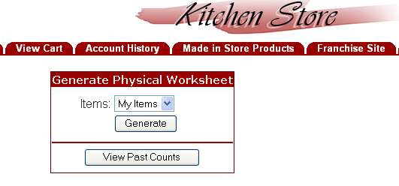

- Update Physical Worksheet
  - Entering the item counts
  - Selecting which Kitchen discounts to apply
  - Create Inventory Valuation PDF Report
  - Printing the Inventory Valuation Report
  - Finalize the counts
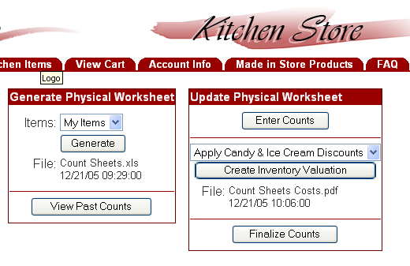

Getting Started

Step 1a – Selecting the Items to Count

When preparing to take a physical inventory you must first decide which items you will count. The options available from the dropdown box include:

My Items
All Items

We recommend that “My Items” are selected in this step so that only those items (Kitchen & MIS) in your store are included on the counts sheets. It is highly recommended that time be taken to make sure every kitchen item and every MIS item is set up as a “MY Item” before proceeding. If you overlook an item that was to have been set up as a “My Item”, it can still be counted and recorded in a later step.

Once you begin using the Physical Inventory feature, you can stop at anytime and not lose any steps already performed or lose any data as long as you do not complete the last step (2e) of “Finalize Counts”. This means you may move to different applications within the Franchise Site or on your computer, to other sites on the internet, or even log off your computer and shut it down without losing data. When you return to the Physical Inventory feature, you will be able to continue where you left off.

Step 1b – Generating the Count Sheet File

Once you make your selection of what items to count, click on Generate. The system “captures” this data, creates an Excel spreadsheet and stores it for printing and subsequent data entry. The captured file name and date will be displayed below the Generate button. This file name is a link to an Excel spreadsheet.

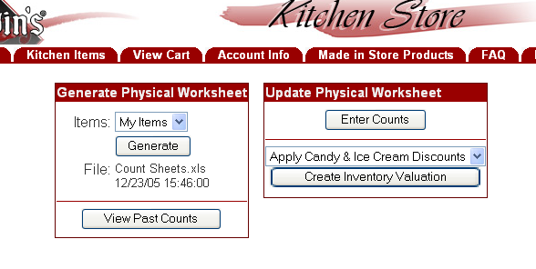
File Name
Generate

The selected items are grouped into the Physical Inventory Categories and allow you to print count sheets and record actual counts on the count sheets as you move through your store.

NOTE: You may only have one “ACTIVE” physical inventory file at a time. Once you capture the items to be counted, the previous “capture” will be erased and a new one created. You must Finalize the previous physical inventory process prior to beginning a new inventory. If you have not completed a prior inventory the system will display a warning message and allow you to erase any partially completed inventory worksheet. Please follow the instructions carefully to avoid losing prior data entry work.

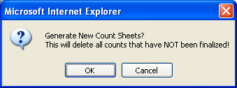

Step 1c – Printing the Count Sheets

Once the Excel data file is created in step 1b, you may click on the file name to open and print the count sheets. Additionally, you can save this file to your local PC for your own analysis or to attach to an email.

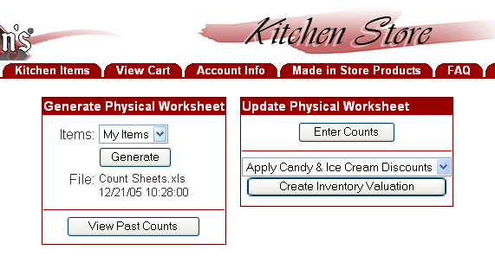
File Name

When you click on the file name the following dialogue box appears.

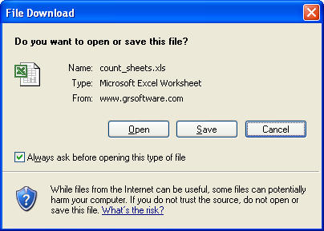

Select the Open option to start Excel and open the count sheet file. When the spreadsheet opens you need to print the count sheets. Simply print the Excel spreadsheet using the print option within Excel.

Each Physical Inventory Category prints on a separate page allowing you to distribute the pages to multiple counters if desired. Working from just one copy of the count sheets is simple and can avoid confusion. However, working from multiple copies can be effective and may be required for large stores or where more than one counter is used. When working from multiple copies, you must keep track of all the sheets and they will each need to be entered in the enter counts phase.

If there are no items for a specific category then no Count Sheet will be printed. For example, if you selected My Items in step 1a and you do not have any Fruits as part of your store’s My Items, then no count sheet would be printed for Fruits. During the entry of the item counts you will have an opportunity to add items to the count sheets that may have been missed during the capture process.

Step 1d – Counting and Recording the Quantities

The next step is to physically count the items in your store and record the actual quantities on the Count Sheets. We recommend you pick a slower time of the day, or when your store is closed, to physically count the items. Doing so, will reduce interruptions and will avoid items moving in and out of the locations as you sell or restock the shelves. The most accurate way to count the items in your store is to have a systematic method of moving from location to location. The best way is to start at one corner, wall, counter or case and methodically move along the area recording quantities. Avoid jumping to different location as you come across items that are stored in multiple locations. Also, if you count an item that is not listed on the count sheet and you want to include this item in this physical inventory, record the item number, description, quantity and cost on the count sheet. You will be able to add the item during the enter counts phase.

It is important to note that you must count the items in the same Unit of Measure that you stock them. Each item has the stocking Unit of Measure listed on the count sheet and you must count the item in that Unit of Measure. For example, item #500 - Milk Tuttle 5# Box, is purchased by the box but priced and stocked in pounds. Therefore, you would weigh the item and record the quantity for this item in pounds. Counting and recording items using the incorrect Unit of Measure will result in an inaccurate and incorrect inventory valuation.

Step 2a – Entering the Counts into the System

Once a count sheet is completed you may enter the counts into the system. You do not have to wait until all count sheets have been completed. You may enter the actual counts into the system as you complete the sheets. Select the Enter Counts option under the Update Physical Worksheet as shown below.

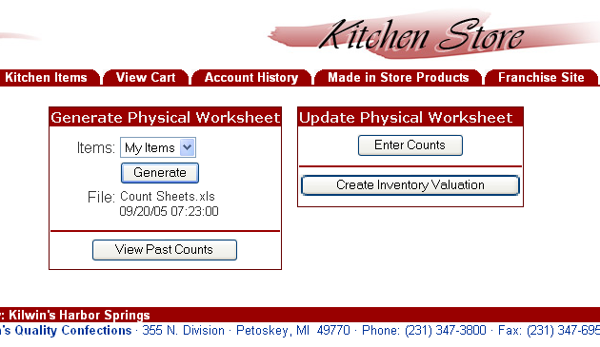

The Enter Item Counts screen will be displayed as shown below. The items are displayed for a specific Physical Inventory Category. Use the Dropdown box to select the category for the counts you wish to enter. The dropdown box reflects the same categories used for the count sheets. Only the items for that category will be displayed.
Dropdown Box
Unit of Measure
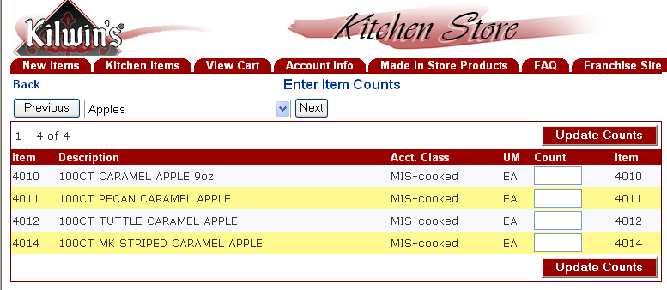

Enter the counts for each item in the Count field on the right side of the page using the TAB key to advance to the next quantity entry box. Use decimals to indicate partial units of measure. You can enter multiple counts of the same item in the count box, separated by spaces, and the system will calculate the sum. For example,

entering “12 space bar 10 space bar 5 space bar“ then the “enter key” or the Update Counts Button will result in a quantity of 27 for this item. Once you have entered quantities for items, be sure to click on the Update Counts Button to record your entries. You may suspend data entry at any time and your counts will be saved in the system providing you have clicked on the Update Counts Button.

Once you have entered the counts (enter a zero count for any item that had a zero physical count in your store) for all items in a particular item class, the system will add the word “Counted” to the category name.
Update Counts Button

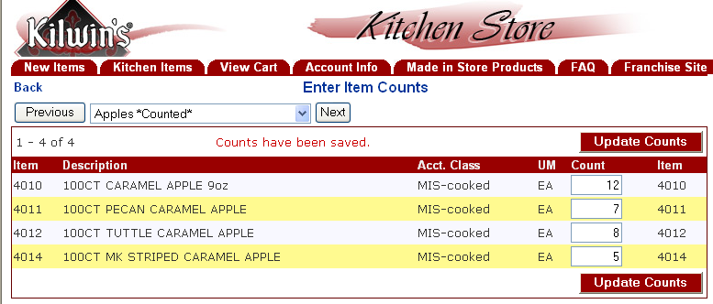

You may enter the counts in any order you prefer moving from one category to the next. Use the dropdown option or the “Previous” and “Next” buttons to select a Physical Inventory Category. After you enter the counts and hit the Update Counts button quantities are recorded and saved in the system. You may return to any category and edit any count at any time. You may exit the Physical Inventory system at any time and return to finish the data entry.

It is highly recommended to click on the update counts button before exiting the Physical Inventory system to ensure that you have saved all data entry.

Entering Counts for Other Vendor Items, Missing Kilwin’s Items and Discontinued Kilwin’s Items

The physical inventory system allows you to count items not part of the capture process including items purchased from other vendors, Kilwin’s items not part of the “My Items” selection as well as Discontinued Kilwin’s items.

Entering Counts for Other Vendor Items

Use the dropdown box and select a category for Other Vendor.

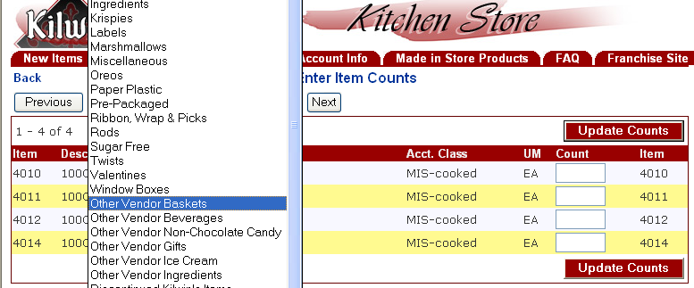

For example, if you have a unique basket to be included in the inventory valuation, selecting the “Other Vendor Baskets” category will display the following screen:

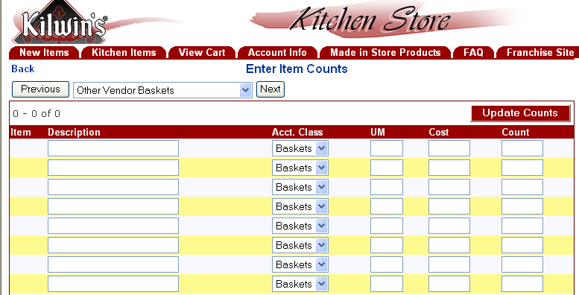

For each unique basket counted (in the example below – Mother’s Day Basket), enter the description, unit of measure, unit cost and count and click Update Counts. The accounting class field may not be changed in all “Other Vendor” categories. All “Other Vendor” items will require you to know the item’s cost. These items will be included in your inventory totals as well as shown on the printed valuation report.

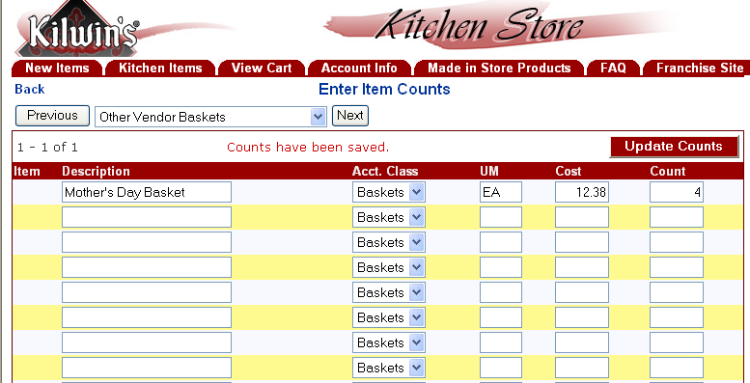
Description, Unit of Measure, Cost & Count

Upon clicking “Update Counts”, the Physical Inventory system will “remember” the items you entered in the “Other Vendor” categories and the items will be included on the counts sheets for the next inventory period. If at that time you do not stock the item, in the Enter Counts step, simply highlight the item description, press the delete key, press the Update Counts button and the item will no longer appear on subsequent count sheets.

Certain “Other Vendor” categories include hard coded items that we assume you purchase from other vendors. An example of this is Other Vendors Beverages. While Coke products are not available for purchase from the Kitchen, the system “hard codes” several of these products assuming you will carry them in your store and want to include them in your count.

In addition to these “hard coded” items there are empty spaces to add items to this category (Pepsi is used in the example). Enter the item’s description, unit of measure, unit cost and count and click “Update Counts”. These items will be included in your inventory totals as well as shown on the printed valuation report. Upon clicking “Update Counts, the Physical Inventory system will “remember” the items you entered in the “Other Vendor” categories and the items will be included on the counts sheets for the next inventory period. If at that time you do not stock the item, simply highlight the item description, press the delete key, press the Update Counts button and the item will no longer appear on subsequent count sheets.
A sample of the screen is shown below.

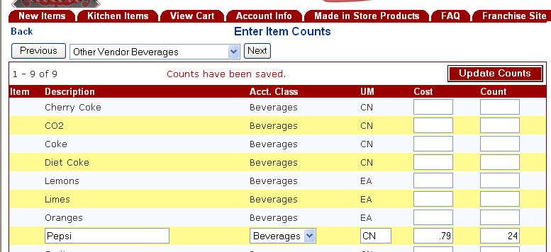
Hard Coded Items

Description, Unit of Measure, Cost & Count

Entering Counts for Missing Kilwin’s Items

Inevitably, there will be several items (Kitchen & MIS items) that you stock that were not set up as “My Items” prior to printing the count sheets. As you come across these items during the counting process, record the item number, unit of measure and count on a blank sheet. These items can be easily entered during this step and you will also have the option of making these missing items a “My Item”.

Use the dropdown box and select the category Add Missing Kilwin’s Items.

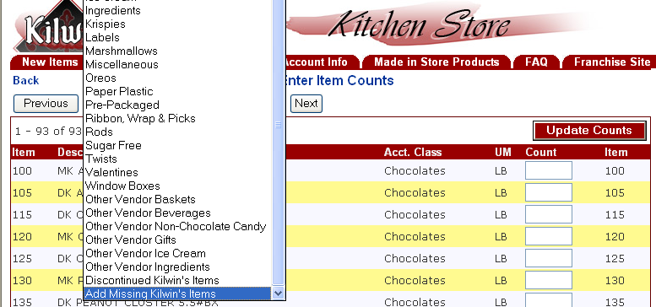

For example, if you stock item #110 – Dark Cashews Clusters, but did not have this item set up as a “My Item” when the count sheets were printed, selecting “Add Missing Kilwin’s Item” will display the following screen:

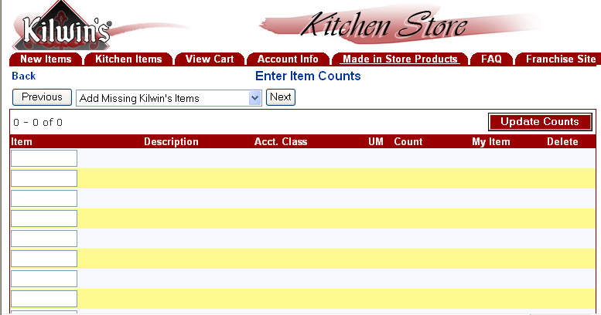

At this step, you may Enter the Missing Item Number(s) one at a time or in batches, then click “Update Counts”.

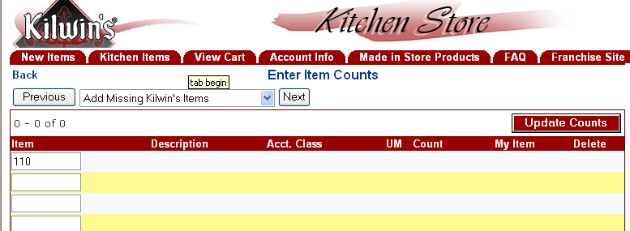

The following screen will be displayed which confirms the item description, assigned accounting class, unit of measure and a field to enter the missing item’s count. Enter Count and click on “Update Counts”. The item and count will now appear in its appropriate Physical Inventory Category (in this example – chocolates).

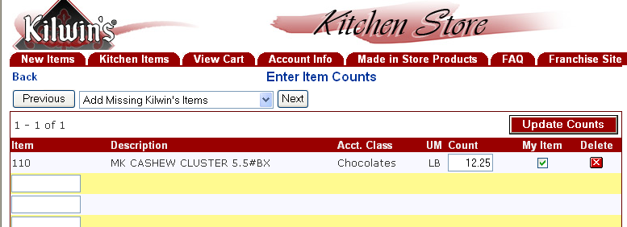
Delete Button
My Item Box

If this is an item you intend to continue to stock and reorder, you may make the missing item a “My Item” by checking the “My Item” Box. Performing this step will ensure that the item will appear on the next physical inventory count sheets.

The Delete Button may be used to delete an item entered in error.

Entering Counts for Discontinued Kilwin’s Items

There will be occasions when a discontinued Kitchen item is still in stock at your store and you wish to count and include it in the inventory valuation. Once an item is discontinued at the Kitchen and the stock depleted, the item is removed from the Kitchen Order page. If the item is not available on the kitchen order page, it will not be printed on the count sheets and it can not be entered as a Missing Kilwin’s Item as described in the previous step. The Discontinued Kilwin’s Items can be entered during this step.

Use the dropdown box and select the category Discontinued Kilwin’s Items.

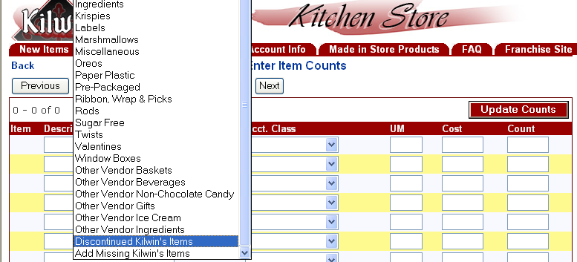

For example, if you stock item #1428 - 2005 Spring/Summer Ribbon, you will find that it has been discontinued at the Kitchen. Selecting the Discontinued Kilwin’s Item category will display the following screen should you wish to count and include the item in the inventory valuation:

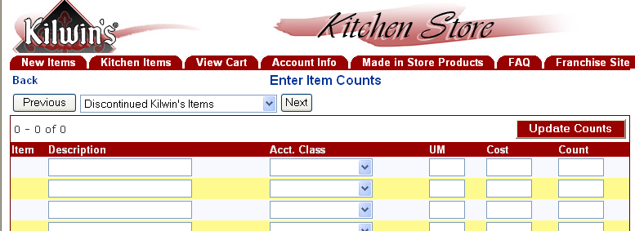

At this step, determine and enter the discontinued Kilwin’s item’s description, accounting class, unit of measure, cost and count then click “Update Counts”. Use the dropdown list to select the correct Accounting Class. You will have to get the cost information from a previous invoice (available online in the Kitchen Store under the Account Info tab) and may wish to take discounts into consideration when entering the cost.

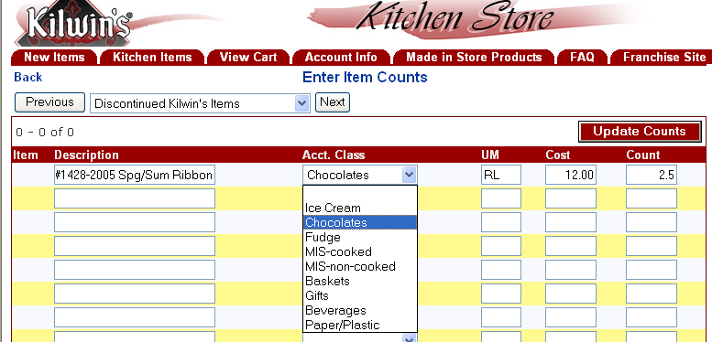
Accounting Class Dropdown List

Upon clicking “Update Counts”, the Physical Inventory system will “remember” the items you entered in the “Discontinued Kilwin’s Items” category and the items will be included on the counts sheets for the next inventory period. If at that time you do not stock the item, in the Enter Counts step, simply highlight the item description, press the delete key, press the Update Counts button and the item will no longer appear on subsequent count sheets.

When all counts have been entered, you may wish to print this worksheet for review and analysis. To do this, click File, Print, select the printer, page range, etc.

Step 2b - Selecting Which Kitchen Discounts to Apply

From the Enter Item Counts screen select the Back button to return to the Physical Inventory Worksheet page.

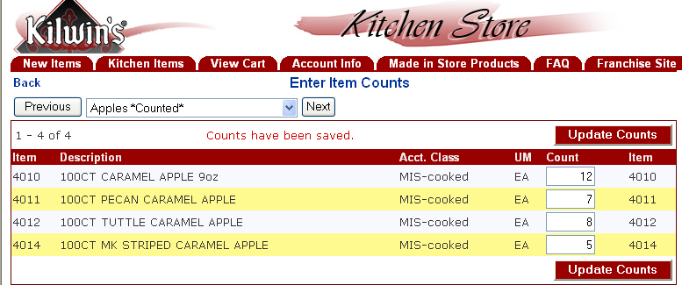

This step allows you the option of selecting which Kitchen discounts you would like applied for the valuation process. The Discount Options may be found in the dropdown list.

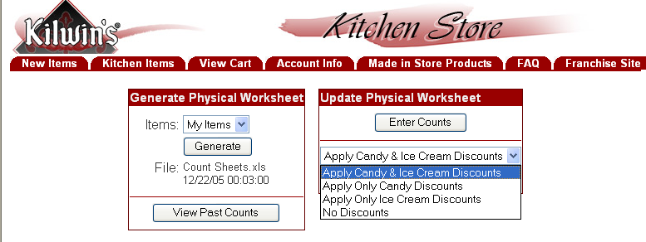

Choose one of these options if you wish to apply a candy discount (2%) and/or ice cream discount ($3.50) to the standard Kitchen cost of the items on your count sheets. The discount will be applied in the Create Inventory Valuation step.

Step 2c – Creating the Inventory Valuation PDF Report

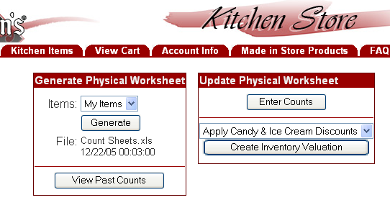

Select the Create Inventory Valuation option from the Update Physical Worksheet panel. This option collects the item and count information you entered in the previous steps and creates a PDF document for reporting the inventory valuation. Each time you select this option a new PDF file is created and the PDF File Name is displayed on the screen.

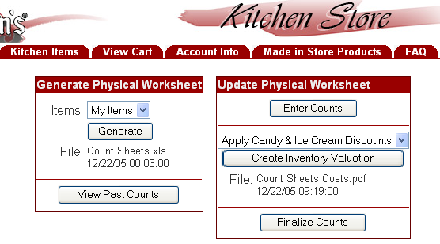
PDF File Name

To review the Inventory Valuation report, click on the PDF file name which will launch Adobe Acrobat reader on your PC and display the following Inventory Valuation report. You may print the report using the PDF Print Icon.

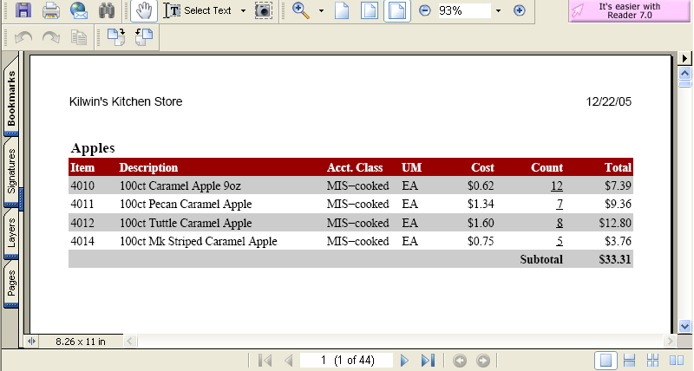
Scroll Bar
Page Buttons

The Inventory Valuation report contains a separate page for each Physical Inventory category and displays the item number, description, accounting class, unit of measure, unit cost, count, extended valuation by item and subtotal. If you select to apply Kitchen discounts, the discounts will be reflected in the unit cost. You can navigate through the document by using the scroll bar on the right and the page buttons on the bottom.

If you do not enter a count for an item, the system will assign a zero count to it.

It is recommended that you review the Inventory Valuation report, by item, at this time. This can be done by either scrolling through and reviewing each item on the screen or printing and reviewing the document using the PDF print icon. If you discover count, unit of measure or data entry mistakes, omissions, or any other errors, you can return to the Enter Counts step and make corrections.

Each time you select the option to Enter Counts and update your count file, the system removes the prior Inventory Valuation report and you must select the Create Inventory Valuation button to generate a new Inventory Valuation report. This process may be repeated as many times as you like until you are satisfied and with the item counts and valuations.

A summary section at the bottom of the Inventory Valuation report groups all item extension amounts by Accounting Classification. This summary shows the accounting class as well as the total extended inventory dollars for each accounting classification. The summary section will display as follows:

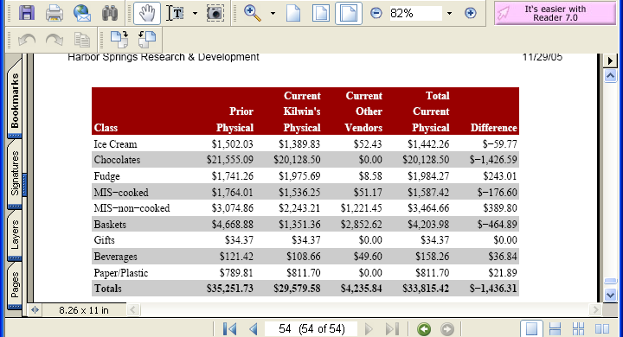

The summary section rows list each of the Accounting Classifications. The columns list:
- Prior Physical - Reflects the extension amounts by accounting classification from the last recorded physical inventory. Your first physical inventory using this system will reflect zeros in this column.
This column reflects your store’s Ending Inventory values from your last physical inventory. This column is your store’s Beginning Inventory value for this inventory period.

- Current Kilwin’s Physical – Reflects the extension amounts by
accounting classification for Kilwin’s Kitchen & MIS items counted in
your store for this inventory period.

- Current Other Vendors – Reflects the extension amounts by
accounting classification for products counted in your store that were purchased from other vendors for this inventory period.

- Total Current Physical - Reflects the sum of Current Kilwin’s Physical and Current Other Vendors by accounting classification. This column is your store’s Ending Inventory value for this inventory period.
NOTE: This column will automatically roll to become your Beginning Inventory value for the next physical inventory.

- Difference – Reflects the difference between Total Current Physical and Prior Physical by accounting classification. Use this column to make adjustments to your Cost of Goods Sold and Inventory Accounts.

Step 2d - Printing the Valuation Report

Clicking on the PDF file name located under the Create Inventory Valuation button
will launch Adobe Acrobat reader on your PC and display the Inventory Valuation report. You may print the report using the PDF print icon or click File, Print, select the printer, page range, etc.

You can also save the Inventory Valuation report to your local PC for later analysis or to attach to an email.

If you discover count, unit of measure or data entry mistakes, omissions, or any other errors during this step you can still return to the Enter Counts step and make corrections and create a new Inventory Valuation report. This process may be repeated as many times as you like until you are satisfied and with the item counts and valuations.

Step 2e - Finalize the Counts

Once you have entered all the counts, printed the Inventory Valuation report and are happy with the results, you should Finalize Counts. This option saves the current counts to a history file and clears the counts in preparation for the next physical inventory.

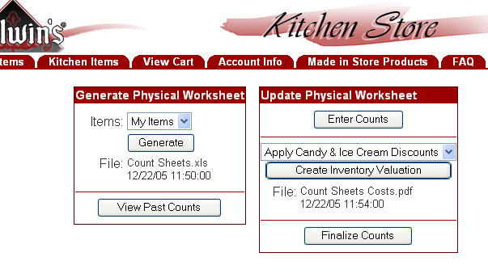
Finalize Counts
When the Finalize Counts option is selected a warning screen is displayed to verify you have completed the inventory, printed the Inventory Valuation report and are ready to complete the inventory. If you have not entered counts for all items within a Physical Inventory category the system displays this warning message:

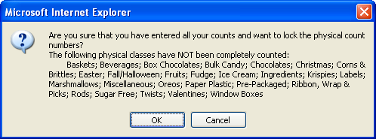

NOTE: You may continue to finalize the counts by selecting OK. However, selecting OK will lock all counts and you will not be able to make changes to the count sheets and Inventory Valuation report without re-entering all count sheet data. You may return to the inventory system to make additional changes by selecting CANCEL.

The warning message also provides you with a final check by listing any physical inventory classes that have NOT been completely counted. Failure to enter any value in any count field will flag the system to notify you of a potential data entry oversight.

Once you Finalize Counts the system will return to the Main Inventory Screen with options available to begin a new Physical Inventory.

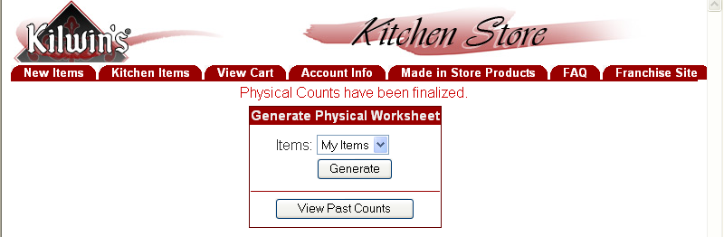

Past physical inventory valuations are available to view and print. Selecting the View Past Counts option will display a list of all past physical inventory valuations showing the date, time, items counted, user name, and item valuation file name. The following screen will be displayed:

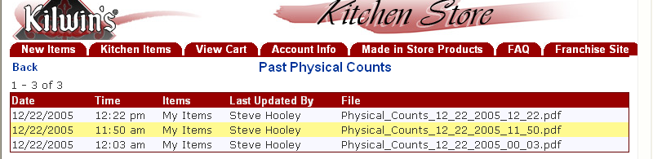

To view a past inventory valuation, click on the File Name.

